Custom PCB Design

- A list of all the electronic components that will be soldered to your PCB
Reference | Qty | Value | DNP | Exclude from BOM | Exclude from Board | Footprint
Brd1 | 1 | SSD1306 |  |  |  | SSD1306:128x64OLED
BT1 | 1 | Battery_Cell |  |  |  | Connector_PinSocket_2.54mm:PinSocket_1x02_P2.54mm_Vertical
D1 | 1 | NeoPixel_THT |  |  |  | Connector_PinSocket_2.54mm:PinSocket_1x04_P2.54mm_Vertical
D2,D3 | 2 | LED |  |  |  | LED_SMD:LED_0805_2012Metric_Pad1.15x1.40mm_HandSolder
M1 | 1 | Stepper_Motor_bipolar |  |  |  | x27_Footprint:x27_stepper
R1,R2 | 2 | 85Ω |  |  |  | Resistor_SMD:R_0805_2012Metric_Pad1.20x1.40mm_HandSolder
SW1 | 1 | SW_SPDT |  |  |  | Connector_PinSocket_2.54mm:PinSocket_1x03_P2.54mm_Vertical
SW2 | 1 | RotaryEncoder_Switch |  |  |  | Rotary_Encoder:RotaryEncoder_Alps_EC11E-Switch_Vertical_H20mm
SW3 | 1 | SW_SPST |  |  |  | Connector_PinSocket_2.54mm:PinSocket_1x02_P2.54mm_Vertical
U2 | 1 | xiaoesp32c3 |  |  |  | GIX_ESP32:XIAO_ESP32

- A screenshot of your circuit in the Schematic Editor window of KiCad
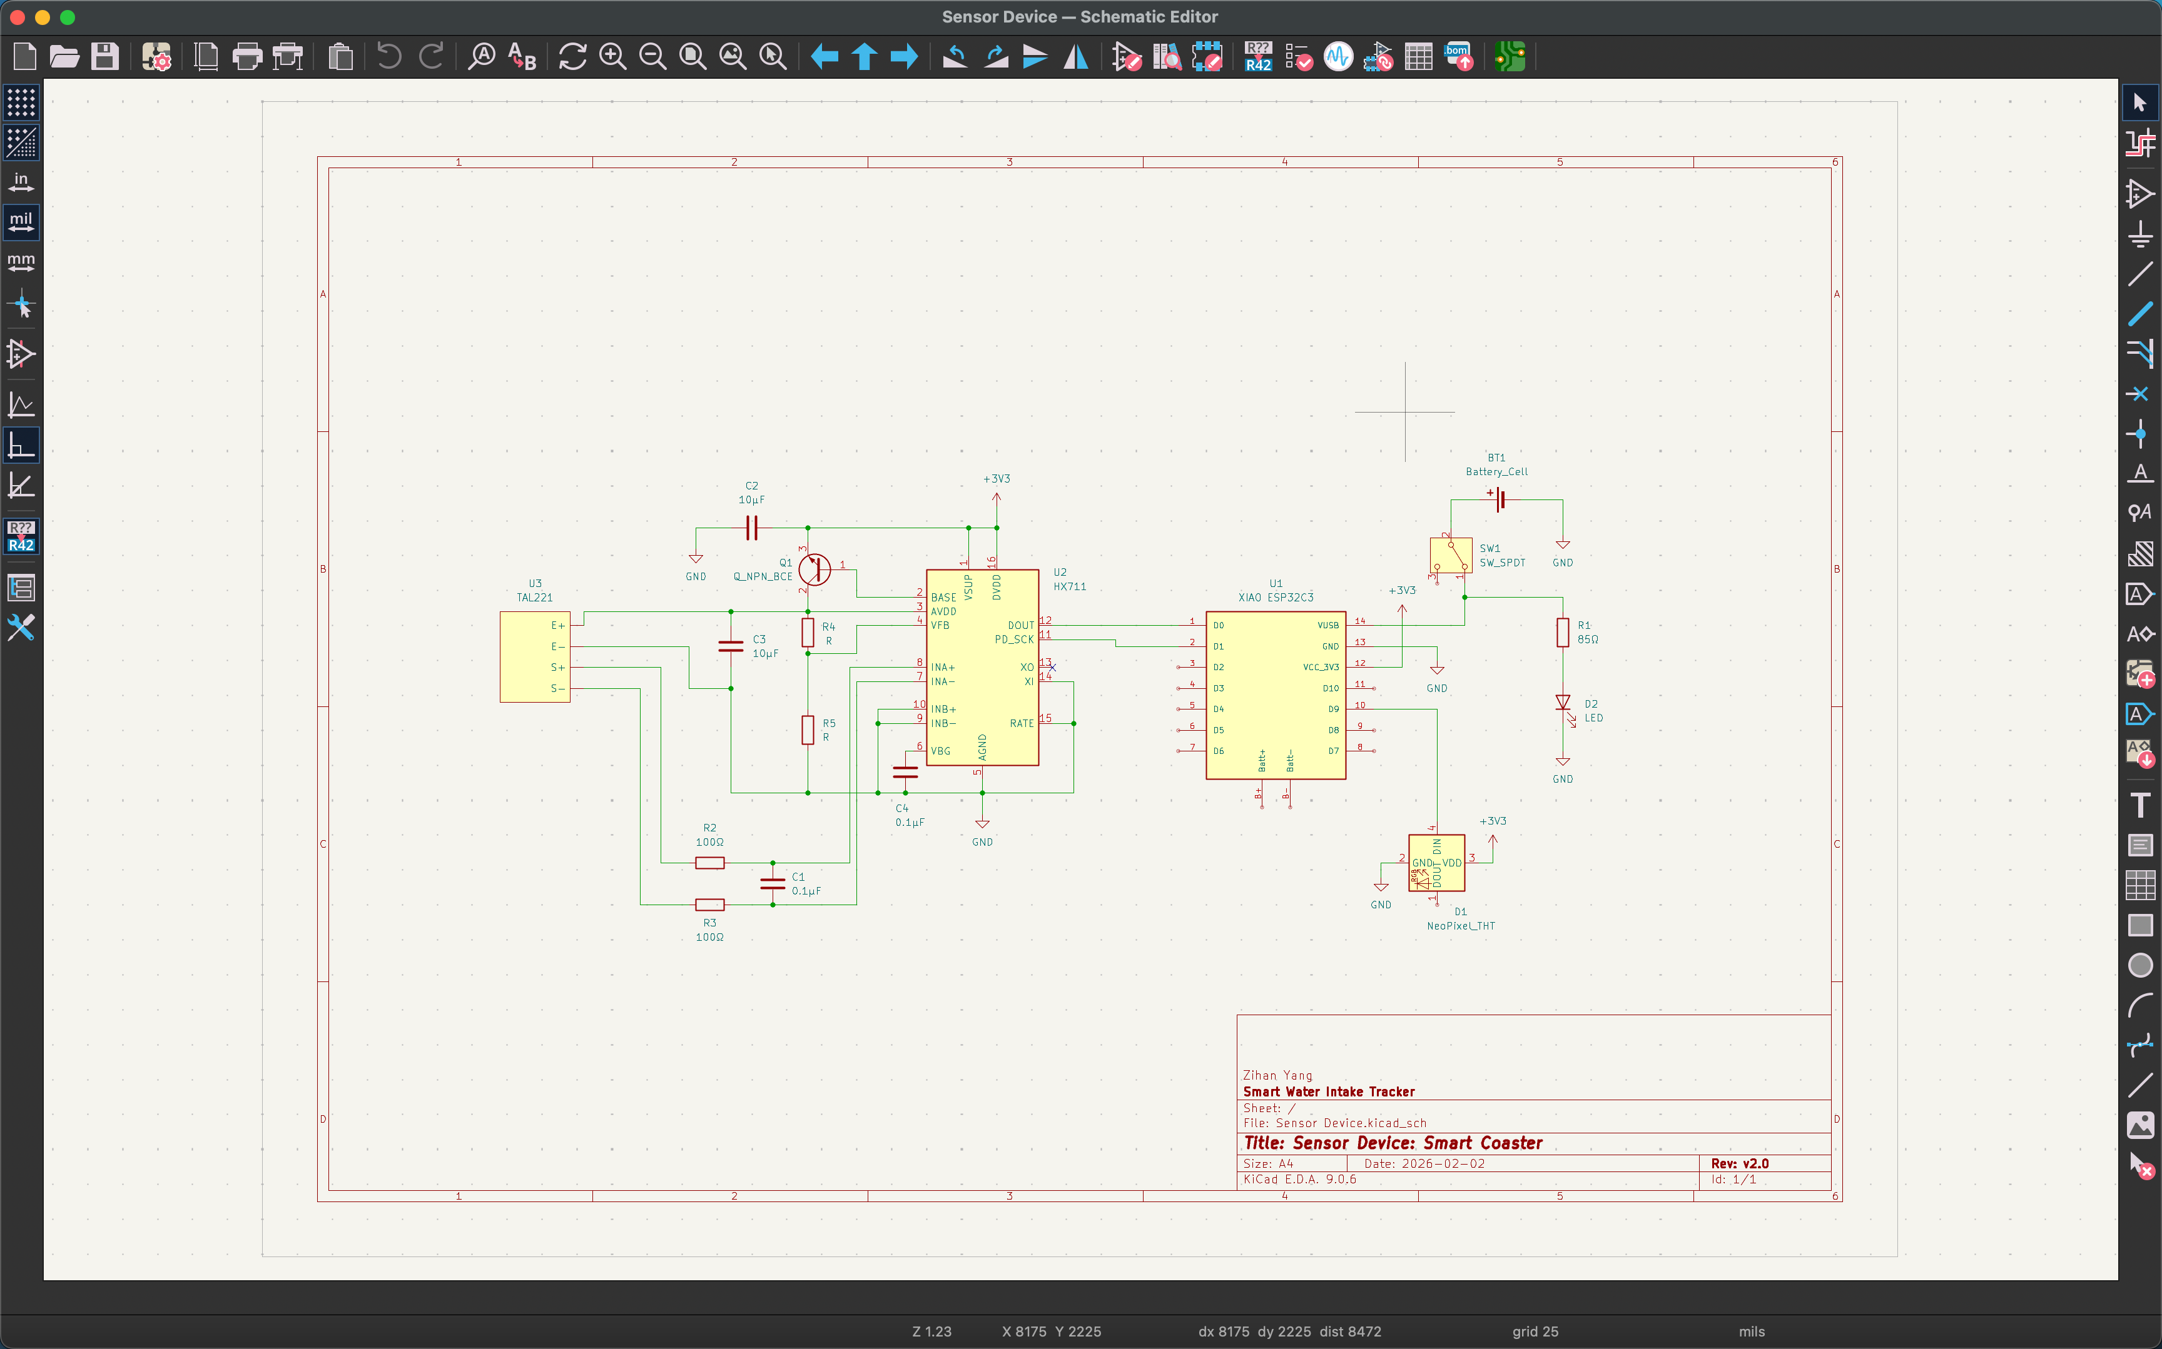
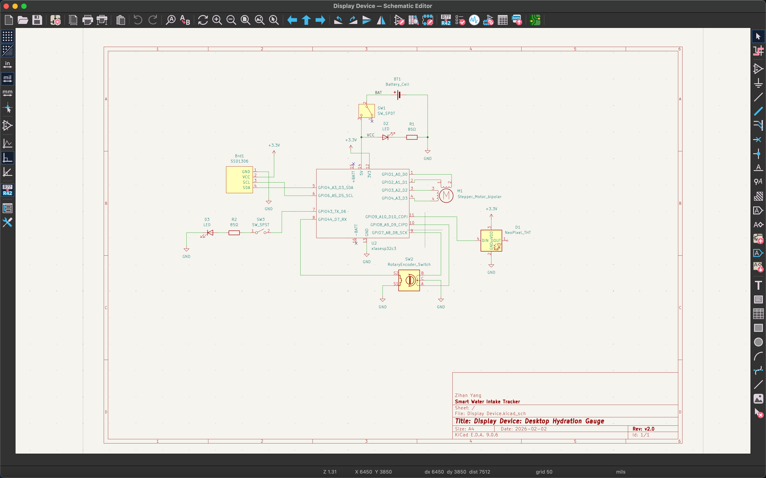
- A screenshot of your circuit board in the PCB Editor window of KiCad
